# ENG10-APR

Automatic Parking Receipt

* Design Requirements

1. Detect if the car is there. Detects a change in color by utilising the light sensor.
2. Determines the length of time the car is parked.
   1. Can be used with a further algorithm to calculate the price of the parking ticket for the car.
3. Adafruit not sensitive to changes in brightness (reduced accuracy in determining if the car is there).
   1. **Should detect change in colour instead of a change in brightness.**

* Materials

1. Begin

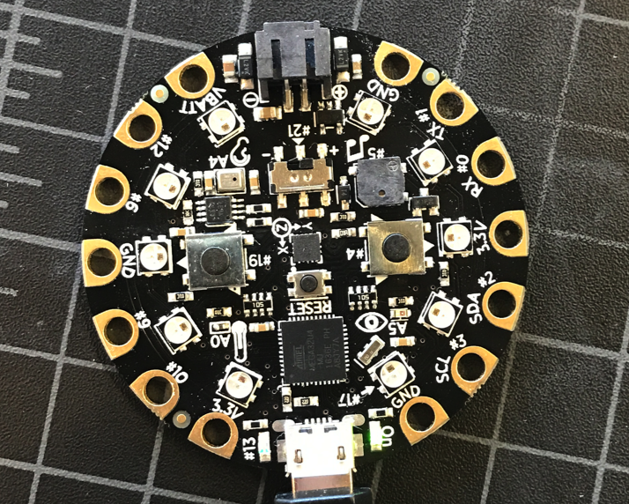

1. Senor Reading Color

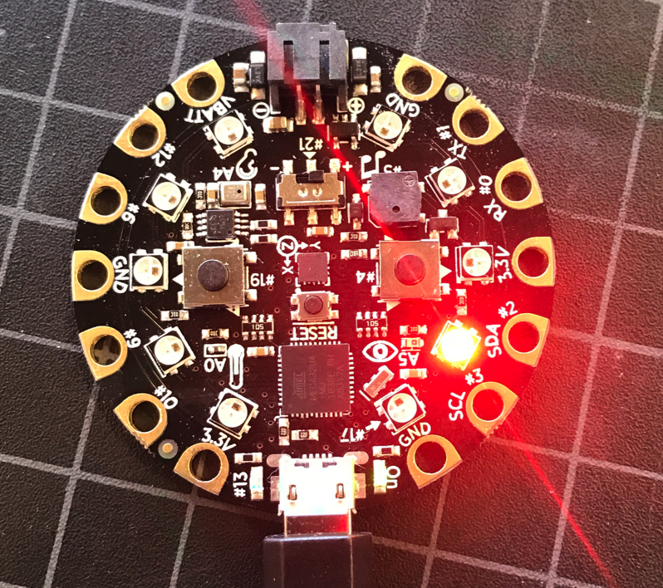

(red -> blue -> red)

1. Senor Confirming Car

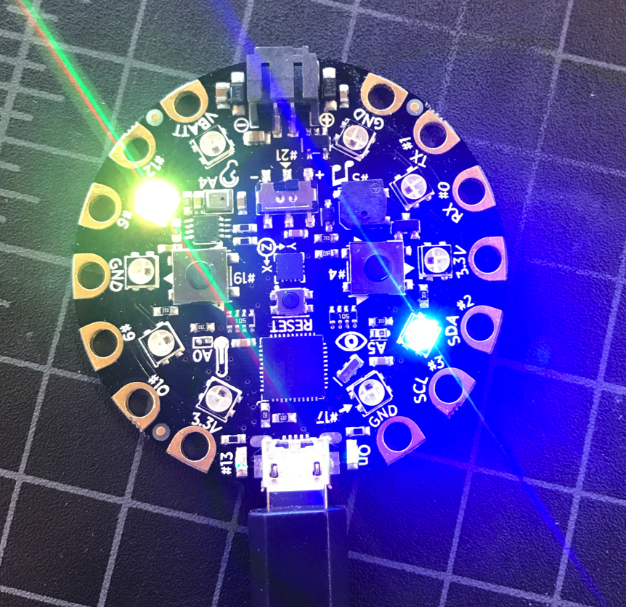 -> 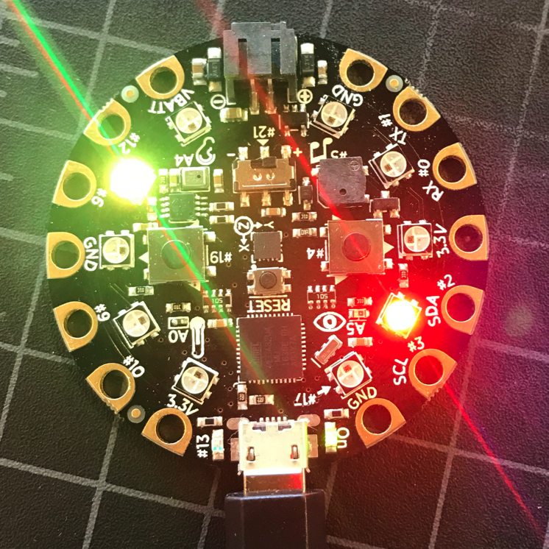 -> 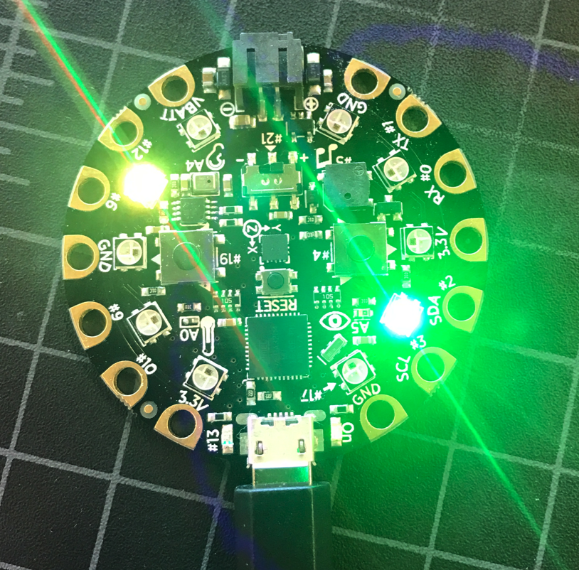

When green light is on, which means something is on the parking space

1. Finally

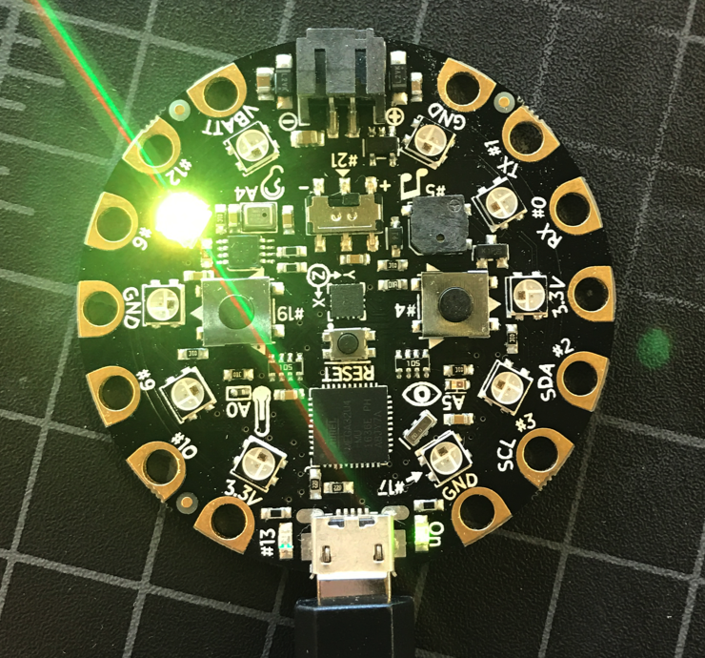

(Car is on the parking space)



(After car leaves, the light will be off, and show the parking receipt)

* Sample Output

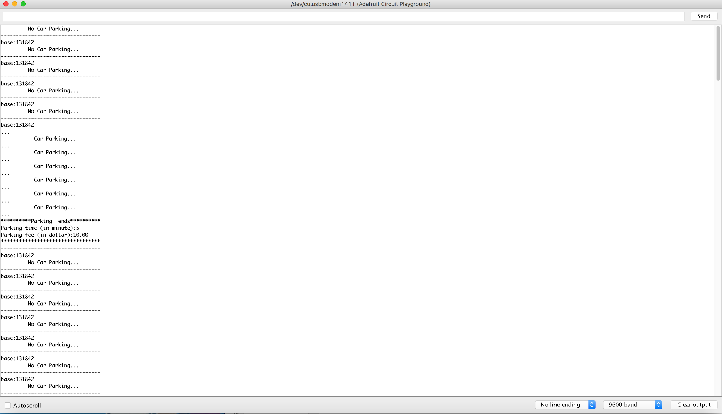

* Future
  + We can use a real time clock to countdown the time.
  + We can utilize different light sources (ex. laser).
  + The shape of the circuit board bothered us a lot, a smaller sized sensor would be more practical.
  + An outer protective shell for the sensor would increase durability.